Record of Likely Significant Effect

Regulation 61 of the Conservation of Habitats and Species Regulations 2010, Statutory Instrument 2010/490

Title: Emergency repairs to Withernsea Long Sea Outfall

Applicant:
Yorkshire Water Services Ltd

Reference No: MLA/2017/00249

Date: 24 July 2017

Location

Withernsea Long Sea Outfalls, East Riding of Yorkshire
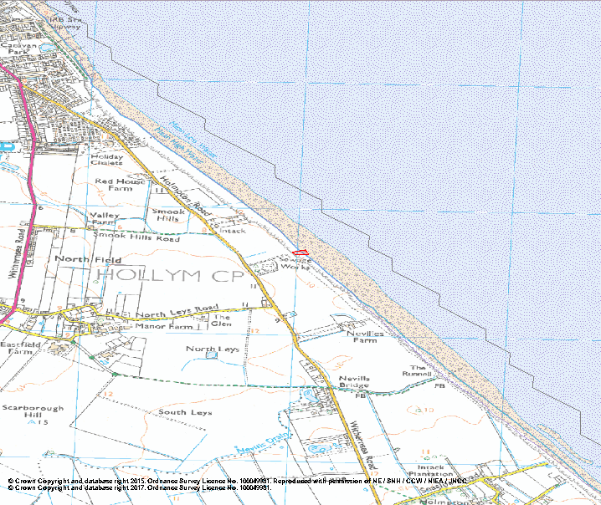

Project Description
The proposed works will involve the placement of rock armour bags at the base of the cliff and further rock armour bags along the route of the failing Long Sea Outfall pipeline.

All materials will be transported to a lay down area on the cliff prior to placement. No materials will be stored on the beach or foreshore.

Pipeline protection
Rock filled bags will be positioned for the full length of the exposed pipeline (approximately 100m) to the lower foreshore where the remains of a construction shaft are located. Bags would also be arranged around this structure.

Bags placed over the pipeline would be expected to raise the profile of the foreshore by approximately 800mm above beach level along the centre line of the outfall structure.

No excavation of the foreshore would be required.

Cliff protection
At the base of the cliff, bags will be deposited in a layered arrangement to a height of 1.5 metres which is half the height of the cliff. The bags are highly flexible and would mould to the uneven contours of the cliff and pipeline.

European marine sites (EMS) and Ramsar in vicinity of proposed works
The following EMS is located in the vicinity of the proposed works (approximate distance in brackets):

- Greater Wash potential Special Protection Area (pSPA) (0 metres)

Further information regarding these sites and their protected features can be found at:
https://consult.defra.gov.uk/natural-england-marine/greater-wash-potential-special-protection-area-com/supporting_documents/V9%20FINAL%20Greater%20Wash%20Departmental%20Brief%2017%20October%202016%20ready%20for%20consultation.pdf

The conservation objectives of Greater Wash potential Special Protection Area (pSPA) site are:

With regard to the potential SPA and the individual species and/or assemblage of species for which the site may be classified (the ‘Qualifying Features’ listed below), and subject to natural change;

Ensure that the integrity of the site is maintained or restored as appropriate, and ensure that the site contributes to achieving the aims of the Wild Birds Directive, by maintaining or restoring;

- The extent and distribution of the habitats of the qualifying features;
- The structure and function of the habitats of the qualifying features;
- The supporting processes on which the habitats of the qualifying features rely;
- The population of each of the qualifying features, and;
- The distribution of the qualifying features within the site.

Qualifying Features:
A001 Gavia stellata; Red-throated diver (Non-breeding)
A065 Melanitta nigra; Common scoter (Non-breeding)
A177 Hydrocoloeus minutus; Little gull (Non-breeding)
A191 Sterna sandvicensis; Sandwich tern (Breeding)
A193 Sterna hirundo; Common tern (Breeding)
A195 Sternula albifrons; Little tern (Breeding)

Is the proposal directly connected with or necessary to the management of the site for nature conservation?
No

Is the proposal likely to have a significant effect 'alone and/or in combination' on a European or Ramsar site or Annex 1 species or habitat?

Interest feature | Potential hazard | LSE? | Potential exposure to hazard and mechanism of effect/impact if known
Greater Wash pSPA
Red-throated diver Gavia stellata (Non-breeding) | Noise during activity Visual/human disturbance during activity | No impact anticipated | The works are of relatively small scale and short term. The deposit of rock armour bags is not likely to generate a significant amount of noise.
Common Tern Sterna hirundo (Breeding) | Noise during activity Visual/human disturbance during activity | No impact anticipated | The works are of relatively small scale and short term. The deposit of rock armour bags is not likely to generate a significant amount of noise.
Sandwich tern Sterna sandvicensis (Breeding) | Noise during activity Visual/human disturbance during activity | No impact anticipated | The works are of relatively small scale and short term. The deposit of rock armour bags is not likely to generate a significant amount of noise.
Little tern Sterna albifrons (Breeding) | Noise during activity Visual/human disturbance during activity | No impacts anticipated | The works are of relatively small scale and short term. The deposit of rock armour bags is not likely to generate a significant amount of noise.
Common Scoter Melanitta nigra (Non-breeding) | Noise during activity Visual/human disturbance during activity | No impact anticipated | The works are of relatively small scale and short term. The deposit of rock armour bags is not likely to generate a significant amount of noise.
Little Gull Hydrocoloeus minutus (Non-breeding) | Noise during activity Visual/human disturbance during activity | No impact anticipated | The works are of relatively small scale and short term. The deposit of rock armour bags is not likely to generate a significant amount of noise.

In-combination Impacts

MMO have considered the in-combination effects with other projects and of the works. Due to the nature of the works which is the deposit of rock material for coastal protection, there is no potential for in-combination effects on the designated sites to occur from the works, as this is a temporary activity.

Conclusion

Based on the fact that no significant effect on interest features has been identified, , it is the MMO’s opinion that if the works are carried out in accordance with the application, the proposal is unlikely to have a significant effect on any SPA or SAC site, either individually or in-combination with other plans or projects. Natural England will be consulted for advice, and this document will be reviewed following advice. The methodology proposed within the application will be ensured through appropriate conditions on any licence that may be granted.

